How to Quote this article:
AEC06 Leaving traditions behind - formal, acoustic and physical experiment in modern poetry written in English = Mimo tradícií - formálny, akustický a fyzický experiment v modernej poézii písanej po anglicky / Jana Javorčíková, Linda Esteves Hatala.
In Literatura - teatr - kino : problemi dialoga : kollektivnaja monografija / rec. G. J. Karpenko, I. V. Nekrasova. - 1. vyd. - Samara : Izdateľstvo Samarskij Universitet, 2014. - ISBN 978-5-86465-652-5. - S. 375-387.
[JAVORČÍKOVÁ, Jana (80%) - ESTEVES HATALA, Linda (20%)]

LEAVING TRADITIONS BEHIND—FORMAL, ACOUSTIC AND PHYSICAL EXPERIMENT IN MODERN POETRY WRITTEN IN ENGLISH
(By Jana Javorčíková and Linda Estevez Hatala)

Key words: modern poetry, acrostics, palindrome, asemic writing, acoustic poetry, three-dimensional poetry

Abstract: The analytical research study explores avant-garde and untraditional forms of modern and ultramodern poetry written in English. The authors analyse the roots of modernity in poetry of Walt Whitman and Thomas Stearns Eliot as well as the innovative forms of latest poetry that affect its verbal, visual, acoustic and even spatial aspects. The article is based on assumption that collages of genres, styles and techniques are the signs of modern poetry.

Introduction
Writing poetry sometimes means following the tradition, sometimes creating hybrids of old and new and sometimes mere experimentation. Many renowned poets who wanted to leave a trace in the history of literature decided to follow the classic patterns and forms; even more of them, however, pushed the traditional forms to their limits and successfully overcame them, creating thus new literary traditions. In this chapter we would like to have a look at some traditional poetic forms that gave birth to new, experimental and ‟postmodern” tendencies in so called modern poetry written in English of the post-war seven decades.

Traditions revisited
Even though there were many experimental streams of poetry in the English-writing world (not to speak of other parts of the world) in the 19th century, the first true experimenters with the form and content of poetry were born in the then new country, the USA. Emily Dickinson (1830—1886) and Walt Whitman (1819—1892), two non-conformist enfants terribles introduced not only new topics (e.g. Dickinson’s ‟sociopathic” poetry) but also new forms (Whitman’s free verse also called verse libre. Free verse later made possible even more extreme forms poetry experimenting with ‟broken” syntax and unusual semantics of modernist poetry, such as:
- discontinuous narrative,
- juxtaposition (contradiction of statements),
- intertextuality (affecting the text’s meaning by some other text),
- fragmentation (incomplete texts),
- parallax (multiple narrative points of view).
Let us observe how some of these phenomena occur in Whitman’s free verse poem As I Ebb’d With the Ocean of Life (1982):

Oppress’d with myself that I have dared to open my mouth,
Aware now that amid all that blab whose echoes recoil upon me I have not once had the least idea who or what I am,
But that before all my arrogant poems the real Me stands yet untouch’d, untold, altogether unreach’d,
[…]
I perceive I have not really understood anything, not a single object, and that no man ever can,
Nature here in sight of the sea taking advantage of me to dart upon me and sting me,
Because I have dared to open my mouth to sing at all. [1, p. 1380].

In this poem, the reader’s attention is first drawn to the irregularities of grammar and syntax. These include not only extremely long sentences and unrhymed endings of lines but also very un-Englishlike use of unfinished statements, beginning of a sentence with a preposition and conjunctions (But, Because), grammatically incorrect use of capital letters (Me, Because) and many others. These formal irregularities, however, are not deliberate—they focus attention on the theme of the piece, most intensely expressed in the lines: ‟I perceive I have not really understood anything, not a single object, and that no man ever can.” Here Whitman uses the fusion of ‟broken” form and verbally expressed doubts of what a man can ever know, undermining the overly optimistic Positivistic beliefs of his times.

Free verse was and still is popular with British authors. Thomas Stearns Eliot (1888—1965; born as an American citizen but naturalized as a British citizen at the age of 29) in his Modernist anti-war Nobel-prize-winning poem The Waste Land (1922) uses free verse, however, he combines it with a rhythmic (almost dialogue-like) exploration of the subject matter [2, p. 301]:
My nerves are bad to-night. Yes, bad. Stay with me.
Speak to me. ‟Why do you never speak? Speak.
What are you thinking of? What thinking? What?
I never know what you are thinking. Think.”
I think we are in rats’ alley
Where the dead men lost their bones.
‟What is that noise?”
The wind under the door.
‟What is that noise now? What is the wind doing?”
Nothing again nothing.
‟Do
You know nothing? Do you see nothing? Do you remember
Nothing?”
I remember
Those are pearls that were his eyes.
‟Are you alive, or not? Is there nothing in your head?”
As we can see in Eliot’s and Whitman’s poems, in free verse the rhythmic cadence is irregular and the rhyme is optional—it may or may not occur and it is used with more freedom. The lines are determined by the quality of the rhythm and not by the syllabic count. The free verse offers a great variety of subject matter and with its use of tone it can come out as rebellion against traditional English metrical patterning.
Let us explore some other innovations in the traditional forms of poetry which, surprisingly, sometimes appeared more than a century ago and are still popular in so called ‟modern” and ‟ultra-modern” poetry.

Experiments with form and meaning
With regard to the enormous variety of poetic experiments in modern poetry written in English, we have decided to divide poems according to the main experimental method used:

Experiments with formal transcription of the poem, such as calligraphy, asemic writing and various forms of visual/concrete/shape poetry: calligrams, centos, diamantes, doggerels, found poems, limericks, acrostics and palindromes. Other experiments may include acoustic and formal experiments and even three-dimensional poetic experiments.

Experiments with formal transcription of the poem
Some of the very early experiments included experimenting with the formal transcription of the poem, raising thus the question, whether the shape of letters affects the meaning of the poem and, consequently, the emotional and intellectual impression it makes. Let us explore those kinds of poetry that use the graphic and visual aspect of the poem to put forward the semantic message to the reader.

A traditional Eastern technique joining the semantic and visual impression of the text is called calligraphy. In contrast to neat calligraphy asemic (i.e. nonsense, having no specific semantic content) writing, rejects the neatness of transcription and denotes a wordless, open semantic form of writing. Reading a poem is then similar to deducing the meaning of an abstract work of art. Some asemic writing includes pictograms or ideograms. Their meaning is sometimes readable (and sometimes not) through their shapes. When looking at asemic writing, the reader is hanging somewhere between reading and looking. Even though asemic writing has no verbal sense, it probably has a textual sense. Its calligraphic form may be understood through aesthetic intuition. Compare in following: calligraphy and asemic writing.

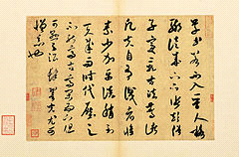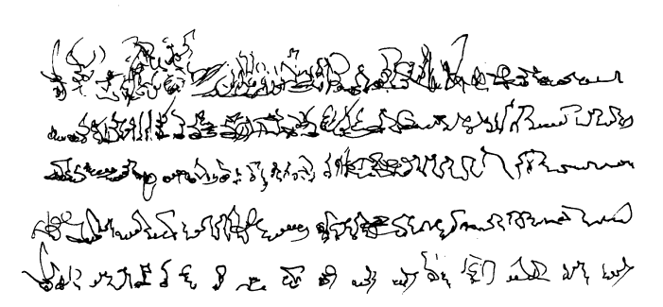

Chinese calligraphy (neat writing) written by Song Dynasty poet Mi Fu (A.D. 1051-1108). [3, p. 1] |  | Asemic (nonsense) writing by Henri Michaux Narration, 1927. [4, p. 1]
Asemic writing appears in international avant-garde literature and art. Artists have practiced this style of writing since the early 1970s, and later it earned popularity in various deciphered scripts and graffiti. Such a form of art has been made by poets, calligraphers, painters, writers and children all around the world. The meaning of asemic writing is open for everyone. Some modern asemic poets writing in English are Jim Wittenberg, Christopher Skinner and Tony Burhouse.

The physical shape of a poem plays an even more important role in so called visual, concrete or shape poetry. Unlike asemic writing, concrete poetry uses meaningful, generally recognized sings (e.g. words) in unusual constellations to intensify the meaning of the poem. Among this type of poetry calligrams, centos, diamantes and doggerels stand out.

A calligram is a type of shape poetry that uses the form of the letters to add to the meaning. The writing or calligraphy is arranged in a way that creates a visual image. The image is a visual demonstration of the theme presented by the text of the poem.
In England, the calligram-style of poetry was written long before the modern age. The 17th century English poet, George Herbert (1593—1633), showed his liking for visual experiments in poetry in his poem Easter Wings [5, p. 1]:

Easter Wings
Lord, who createdst man in wealth and store,
Though foolishly he lost the same,
Decaying more and more,
Till he became
Most poore:
With thee
O let me rise
As larks, harmoniously,
And sing this day thy victories:
Then shall the fall further the flight in me.

My tender age in sorrow did beginne
And still with sicknesses and shame.
Thou didst so punish sinne,
That I became
Most thinne.
With thee
Let me combine,
And feel thy victorie:
For, if I imp my wing on thine,
Affliction shall advance the flight in me. [24]

When printed on a page, the poem resembled butterfly’s wings even more intensely:

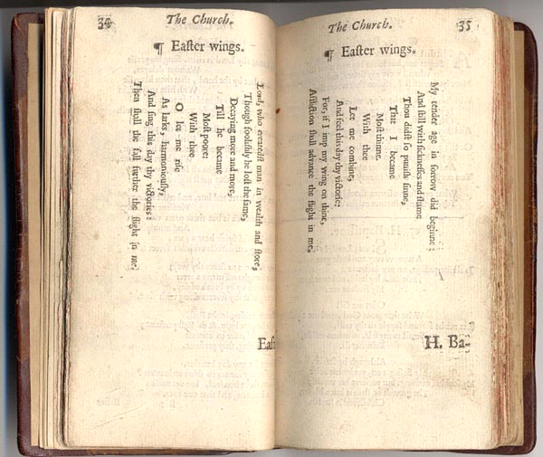
In the 1633 edition the poem is printed as the scanned copy above,
truly looking like its title. [6, p. 1]

Lewis Carroll (1832—1898), as E. Masárová notes [7, pp. 72-73], is a famous fantasy writer but also another famous representative of visual poetry using calligram-like combination of texts and shapes. His famous short poem named The Mouse’s Tale, originally published in his phenomenal novel Alice’s Adventures in Wonderland (1865), takes shape in the form of a mouse’s tail [8, p. 1]:
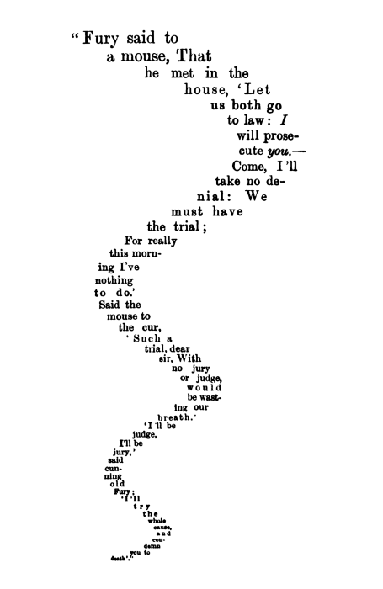
The major contribution of concrete poetry is the fact that it has tried to free itself from the rules of linearity. David Crystal writes, ‟…[concrete] poems are typically two-dimensional though they often make use of a third dimension (such as typographic prominence) and some introduce a fourth such as colour or using animated techniques in television—change in time” [9, p. 1]. That may be exactly what adds to the popularity of concrete poetry; this form of poetry is not only popular for its intriguing graphic design, but also for the intellectual effort a reader needs to make to understand the meaning when the poem can be read in more than one directions.

In modern English poetry, Roger McGough (b. 1937) uses calligrams to put forward the subjects of his poems, which often depicted modern problems of a man in the present-day world, such as isolation, collapse of communication, consumerism and many others. One of his poems entitled 40—LOVE [10, p. 83] observed the physical and emotional gap between a couple in their prime; however, McGough uses the graphic and symbolic effect of a tennis court separated by a net:

40—LOVE
40—  middle  couple  ten  when  game  and  go  the  will  be  tween | love aged  playing nis  the ends  they home  net still  be them

Needless to say, this type of concrete poetry is almost beyond translation.

Another type of innovated traditional poetic form is a cento, a form of poetry made up of lines borrowed from established authors. The effect is usually humorous and the final result of these line-stiches is the change in meaning. It is sometimes called patchwork poetry. Modern centos are very often witty, ironic and humorous and if it is to be a true cento, it must be composed entirely of lines from other sources. Some early examples can be found in the works of Homer and Virgil. Read the cento devised by the Scottish poet Alison Chisholm (1886—1906) for a promotional film of BBC Two, broadcast on Boxing Day 2012 and subsequent months [11, p. 1]:

...Where busy thought and blind sensation mingle. (Percy Bysshe Shelley, Fragment)
Come, my friends, ‘tis not too late, (Alfred, Lord Tennyson, Ulysses)
For we are the movers and shakers
of the world for ever, it seems; (Arthur O'Shaughnessy, Ode)
To strive, to seek, to find and not to yield. (Alfred, Lord Tennyson, Ulysses).

Graphic poetry has many more variants, e.g. a diamante. A diamante is a seven-lined contrast poem set up in a diamond shape. The first line begins with a noun and second line contains two adjectives which describe the noun. The third line consists of three words ending in -ing, and the fourth line has four more words that describe the subject. The use of an antonym for the ending is for the sake of the shift. In the fifth line there are three more -ing words which describe the ending noun of the poem. The sixth line contains two adjectives that modify the last line, which is the first noun’s antonym or synonym.
Noun
Adjective-Adjective
Verb-Verb-Verb
Noun-Adjective / Noun-Adjective
Verb-Verb-Verb
Adjective-Adjective
Noun

The poem is usually used to compare or contrast two different subjects (nouns). We have chosen some rather amusing examples written by the Adult intermediate-level ESOL students at Oregon University:

Man-Woman 1  by Lukacs (male)  Man  Brilliant, perfect  Working, learning, earning  Beer, car, mirror, make-up  Speaking, speaking, speaking  Furious, exhausted  Woman  [12, p. 1] | Man-Woman 2  by Bogi and Eszter (female)  Man  Stupid, rude  Sleeping, eating  Trousers, underpants, knickers, skirts  Working, sporting  Clever, beautiful  Woman  [13, p. 1]

What is perhaps most obvious in both these diamantes is a certain economy of means that accentuates the funny, teasing character of the poems.

To make our list of extreme graphic experimentation in poetry complete, one cannot omit a so called found poem. A found poem is a poem created from prose found in a non-poetic context. The form is patterned on the rhythm, rearranging the lines to appear as a poem. In general, the context from which the lines are taken or found is e.g. advertisements, product labels, newspapers etc.

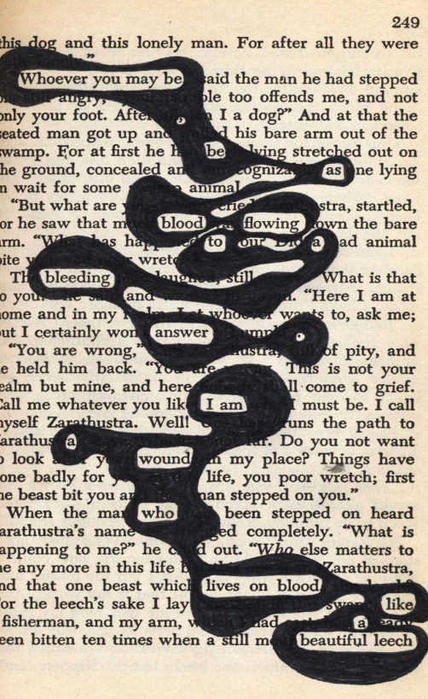 [14, p. 1]
More traditional and historically bound types of visual poetry (where form is as important as content) are represented by popular limericks. A limerick (sometimes described as folk poetry) is a short, humorous nonsense poem, especially in five-line anapestic meter with rhyme—aabba. It goes back to the early years of the 18th century, popularized by Edward Lear (1812—1888) in his first Book of Nonsense in 1845, (he wrote 212 limericks). The origin of the name is referred to the City or County of Limerick in Ireland. The earliest known use of the term ‟limerick” is an 1880 reference, in a Saint John, New Brunswick newspaper, to an apparently well-known tune:
There was a young rustic named Mallory,
who drew but a very small salary.
When he went to the show,
his purse made him go
to a seat in the uppermost gallery.
(Tune: Won’t you come to Limerick). [15, p. 1]

Limericks are sometimes described as rather common forms of poetry and are often obscene with humorous intention. After introducing the first line which traditionally introduces a person and a place, limericks should have a kind of twist, revealed in the final line. Verses are sometimes combined with a refrain to form a limerick song (traditional folk drinking songs with obscene verses).

A clerihew is a form similar to the traditional limerick, a humorous verse which uses a name of well-known person at the end of the first or second line. The inventor of this form was Edmund Clerihew Bentley (1875—1956). His form includes four free verse lines with an irregular prose-like rhythm with two pairs of rhyme (aabb). It is usually biographical and pokes fun mostly at some famous people, but it is not abusive or satirical. The first line may consist solely of the subject’s name. A modern literary example is [16, p. 1]:
Ted Hughes,
Sylvia’s muse
Was rather good-looking.
Let his wife do the cooking.

In 1983, Games Magazine ran a contest titled ‟Do You Clerihew?” The winning entry was [17, p. 1]:
Did Descartes
Depart
With the thought
‟Therefore I’m not?”

Another popular form of poetry experiments with codes hidden within the text of a poem. One of these is known as an acrostic poem. Experiments with form and meaning overlap here as acrostics are forms of writing in which the first letter, syllable or word of each line spells out a word (usually a name) or a message. It can be used for practicing one’s memory, a technique known as ‟mnemonics.” Acrostics were commonly used throughout antiquity, medieval ‟dark ages” and the Renaissance, finally reaching modern times. They can be easily detected in English and German literary language, but they are rare in other languages. During the Renaissance acrostics were used as ‟codes”, in which the authors are trying to conceal the message instead of revealing it. Acrostics were also written by famous English-writing literary figures such as Edgar Alan Poe (1809—1849) and Lewis Carroll (1832—1898).

Acrostics are many times more complex, not only making words from initials but also creating so called double acrostics [18, p. 1]:

Unite and untie are the same—so say you.
Not in wedlock, I ween, has the unity been.
In the drama of marriage, each wandering gout
To a new face would fly—all except you and I
Each seeking to alter the spell in their scene.

The words are at the beginning and at the end of their lines. The most unique form of double acrostic was written by Lewis Carroll for Gertrude Chataway. These verses reveal her name in two ways—by letters and by syllables [19, p. 1]:

Girth with a boyish garb for boyish task,
Eager she wields her spade-yet loves as well
Rest in a friendly knee, the tale to ask
That be delights to tell.

Rude spirits of the seething water strike,
Unmeet to read her pure and simple spright,
Deem, if you list, such hours a waste of life,
Empty of all delight…

Double acrostics should not be confused with palindromes. A palindrome is a word, sentence or sequence of sentences whose meaning may be interpreted the same way in either forward or reverse direction. There are different types of palindromes, e.g. single words (civic, radar, madam, refer) or line units (So patient a doctor to doctor a patient so), phrases or sentences (A nut for a jar of tuna), names—some people have palindromic names (Anna, Ada, Bob, Eve) There are also palindromic numbers (313, 191), dates (21/02/2012, November 22/ 2011). We may consider palindromes to be a ‟fringe-type” of poetry, or rather word games for poets who enjoy arranging words to strange and clever patterns.

Acoustic and formal experiments
The previous list of poems combined form and meaning to intensify their message. However, some modern poets use phonetic experiments which far exceed the “traditional” literary use of figures of sound, such as rhyme, alliteration and onomatopoeia, to name a few. Perhaps the greatest modern experimenter with the sound and semantics of a poem is Edwin Morgan (1920—2010), a Scottish poet and translator, also known for his association with the Scottish patriotic movement called Scottish Renaissance. Moreover, he was a prolific writer until his death in 2010 at the age of ninety. Morgan was involved with the International Concrete Poetry Movement and together with another Scotsman, Ian Hamilton Finlay (1925—2006), became a major representative of concrete poetry in the United Kingdom. One particular poem, which serves as an excellent example of concrete poetry, makes many readers wonder whether it is a joke or a serious piece of poetry [20, p. 1].

Siesta of a Hungarian Snake
s sz sz SZ sz SZ sz ZS zs ZS zs zs z

This poem can be also defined as a sound poem. Sound poetry by definition is an artistic form bridging between literary and musical composition. It is like ‟verse without words”. The Dadaist and Futurist Vanguards were the first pioneers to venture into this realm of poetry. Sound poems later evolved into visual and concrete poems. ‟Siesta of a Hungarian Snake” is basically one verse without words, using phonetic and phonological stylistic devices, e.g. onomatopoeia to illustrate the hissing sound of a snake. Is that all of the content of this poem, or can we go any further with our analysis? If we decide to see certain semantic and syntactic values in it, we can try to scrutinize and explain the meaning of it to some extent. Morgan once said ‟there is a purist side to concrete poetry, which is very different to what I do, and which I like but I felt I wanted to give it a bit more body.” Could this mean that the purist approach in concrete poetry is the extreme simplification of the form and content? What might possibly be the subject matter of the poem Siesta of a Hungarian Snake? The title is certainly more revealing than the actual ‟hissing sound”. Why ‟siesta” and why ‟Hungarian”? It is always a good idea to read and find out more about the author’s life; it can reveal a lot about his inspiration. For instance, the fact that the snake is ‟Hungarian” could be explained by poet’s affinity towards this country and the fact that he also translated from the Hungarian language.
The use of capital letters SZ and ZS must be stylistically significant; it could evoke the intensity of loud snoring sound after feeding. Siesta comes after a big supper—the unfortunate prey is swallowed whole and now it’s being digested by a huge body of a snake. The digestion process is taking place in the middle of a body so the small-case letters at the beginning and the end of the line may illustrate the small head and a tail of the creature. Another theory about the nationality of the snake is that author was playing with the word. The word ‟Hungary” is a homophone and it has the same pronunciation as the word ‟hungry.” These two words differ in meaning and spelling and they can be also called heterographs. Even the lexicographical term evokes a graphic play with the words. Nonetheless, Hungary is not Hungarian so what shall we do with the suffix: -ian? The following idea may certainly sound far-fetched, but what if it is a reference to his friend’s first name Ian (Ian Hamilton Finlay). The fact that the snake is snoring and digesting is in contrast with our analysis of the snake being hungry. We may only assume that the snake is always hungry. Then, however ridiculous the poem might have appeared initially, it is actually telling us a short story: a hungry snake Ian is having a siesta after its/his supper.

Three-dimensional poetic experiments
Let us conclude with perhaps the most extreme poetic experimentation, involving sculptural forms, i.e. the physical space where the poem occurs. ‟Physical” or three-dimensional poetic experiments often overlap with fine art and involve various forms of installations, poem-objects and collages of various materials.

How did the idea of physical poetic experiment emerge? It is a fact that there have been numerous experiments with where and when poetry is read; it got out of theatres and formal reading rooms to less formal cafeterias, students’ dormitories, happenings, poetry-reading evenings and even to commercials and newspaper headings. Some poets experimented even with the material on which a poem is written, challenging the very concept of the traditional notion ‟poem”. They carved their poetry into stone and glass, arranged the letters of poems in various shapes and used unusual materials to express their poetry.

One of the poets who also takes the aspect of shape of a poem into consideration, eventually regarding this type of poetry as a three dimensional visual art, is a Scottish poet and gardener Ian Hamilton Finlay (1925—2006). He composed poems which were inscribed in stone sculptures, lying around in the five-acre garden called Little Sparta in the Pentland Hills near Edinburgh where Finlay created ‟poem-objects” with the help of his wife Sue Finlay. In 2004, the garden was given the attribute ‟the most important work of Scottish art” [21, p. 1].

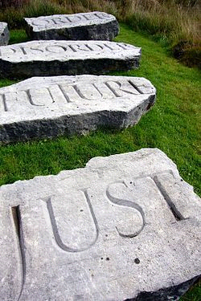
‟The present order is the disorder of the future”
(St Just)—Little Sparta. [22, p. 1]

In doing so, Finlay not only shocks the spectator but forces him/her to question the very fundamentals of traditional poetry.

Our list of modern experiments in poetry is by no means complete. Nevertheless, in this chapter we hope to broaden the horizons of thinking about poetry and poems as stuck in preconceived classical forms and limited to two-dimensional space only. We also hope to allow the reader to see and understand the shift of modern poetry from the historical forms (such as ode, elegy and sonnet) to modern, unexplored ones.

Works Cited
- WHITMAN, W. 1982. As I Ebb’d With the Ocean of Life. In Poetry and Prose. New York : Library of America, 1982. 1380 p. ISBN-10 0940 4500 2X.
- ELIOT, T. S. 2000. The Waste Land. New York : Norton, 2000. 320 p. ISBN-10 039 3974995.
- FU, Mi. Poem Written in a Boat on the Wu River. (Calligraphy). In http://www.metmuseum.org/collection/the-collection-online/search/39919>. (accessed : July 6, 2014).
- MICHAUX, H. Narration.(Asemic writing).
In <http://kalanlar.tumblr.com/post/37988590566>. (accessed : July 16, 2014).
- HERBERT, G. 2014. Easter Wings. (Calligram).
In <http://www.poetryfoundation.org/poem/173626>. (accessed : July 6, 2014).
- HERBERT, G. 2014. Easter Wings. (Calligram).
In <http://www.ccel.org/h/herbert/temple/Easterwings.html>. (accessed : July 6, 2014).
- MESÁROVÁ, E. 2009. Historické východiská zrodu modernej fantastickej literatúry. In Nová filologická revue, 2/2009, vol. 1, no. 2, pp. 72-78, ISSN 1338-0583.
- CARROLL, L. 2014. The Mouse’s Tale. (Shape poetry).
In <http://en.wikipedia.org/wiki/The_Mouse's_Tale>. (accessed : July 16, 2014).
- CRYSTAL, D. 1995. The Cambridge Encyclopedia of English Language. Cambridge : Cambridge University Press, 1995. 506 p. ISBN-10 0521-530 334.
- MCGOUGH, R. 1992. 40-LOVE. In Chapter and Verse. Oxford : Oxford University Press, 1992. 138 p. ISBN 0 19 421713 2.
- CHRISHOLM, A. 2014. Cento. (Cento).
In <http://en.wikipedia.org/wiki/Cento_(poetry) >. (accessed : July 6, 2014).
- ANONYMOUS. 2014. Man-Woman. (Diamante).
In <http://blog.edidablog.it/blogs//index.php?blog=317&cat=1073>. (accessed : July 6, 2014).
- ANONYMOUS. 2014. Woman-Man. (Diamante).
In <http://blog.edidablog.it/blogs//index.php?blog=317&cat=1073>. (accessed : July 6, 2014).
- ANONYMOUS. 2014. Found poem.
In <http://en.wikipedia.org/wiki/Found_poetry>. (accessed : July 1, 2014).
- ANONYMOUS. 2014. There was a Young Rustic Named Mallory. (Limerick). In <http://en.wikipedia.org/wiki/Limerick_%28poetry%29>. (accessed : July 26, 2014).
- ANONYMOUS. 2014. Ted Hughes. (Clerihew). In <http://en.wikipedia.org/wiki/Talk%3AClerihew>. (accessed : July 6, 2014).
- ANONYMOUS. 2014. Did Descartes… (Clerihew).
In <http://en.wikipedia.org/wiki/Talk%3AClerihew>. (accessed : July 9, 2014).
- DOUBLE ACROSTIC. 2014. In <http://en.wikipedia.org/wiki/Acrostic>. (accessed : July 16, 2014).
- DOUBLE ACROSTIC. 2014. In <http://en.wikipedia.org/wiki/Acrostic>. (accessed : July 6, 2014).
- MORGAN, E. 2014. Siesta of a Hungarian Snake.
In <http://circadianpoems.blogspot.sk/2005/11/edwin-morgan.html>. (accessed : July 6, 2014).
- ANONYMOUS. 2004. Little Sparta goes a long way in polls on Scotland’s greatest art. In <http://www.scotsman.com/news/little-sparta-goes-a-long-way-in-poll-on-scotland-s-greatest-art-1-1400569>. (accessed : July 26, 2014).
- FINLEY, H. 2014. Little Sparta. In <http://en.wikipedia.org/wiki/Little_Sparta>. (accessed : July 3, 2014).

