TEACHING SUBTITLING WITHIN TRANSLATION & INTERPRETING STUDY PROGRAMME – DEVISING MODEL FOR “SUBTITLING 101”

Matej Laš

Abstract
This paper deals with the didactics of subtitling. Its aim is to present a teaching model for “Subtitling 101”. The goal of this model is to provide students with basic knowledge about audiovisual translation, subtitling and subtitling software. This course aims to provide students with ability to spot and translate open subtitles for any audiovisual media. The model is based on the competences stated by translation studies scholars as well as on personal experiences. The proposed model can be tailored to teachers’ needs.

Keywords: audiovisual translation, didactics of translation, subtitling

1 Introduction
Huge progress of digital technologies has influenced the world we live in. As Díaz (2008, p. 90) notices: “What we are witnessing is the emergence and settling down of a new medium (audiovisual) as opposed to a traditional one (paper)”. YouTube, social media, TED, Netflix and other online platforms implement subtitles within their products and the amount of videos – adverts, vlogs, news, etc. – is increasing at a fast pace. In other words, monodimensional documents are being turned into multidimensional.
At Slovak universities teaching translation and interpreting, the teaching of subtitling is still on the periphery of attention. Notwithstanding the Constantine the Philosopher University in Nitra – where there have been several studies and monographs published and where audiovisual translation is systematically taught – the audiovisual translation in Slovakia is rather neglected. At the Department of English and American Studies at Matej Bel University, there is only one non-compulsory course dedicated to subtitling.
Although Slovaks’ televisions prefer dubbing to subtitles, Chaume (2013, p. 117) thinks there “was always a demand for original version (subtitled) films from elite audiences”. Since the rise of the Internet, there has been a rather large group of fansubbers making subtitles for their favourite TV series or movies, because demands of viewers have not been met by television. To boot, television is only one media where subtitles or other forms of audiovisual translation is used. The goal of this paper is to introduce general model for Subtitling 101 that can be tailored to teachers’ needs and should help to integrate AVT training into Translation and interpreting study programme.

2 Aims of “Subtitling 101”
If the translation and interpreting community – whether professionals or teachers and scholars – want to influence the quality of subtitling, it is necessary to implement rigorous audiovisual courses tailored for the needs of the market. The aim of the course should be to provide the students with the necessary “subtitling minimum”, let us term it “Subtilitng 101”.
In order to define the specific aims of the course, theories dealing with the competences needed for subtitling are taken into account. Janecová (2014, p. 54) takes into consideration the contemporary demands of media and translation market as well as the specifics of subtitling. She also takes into account competences defined by the expert group EMT (European Master’s in Translation) and expert group OPTIMALE (Optimising Professional Translator Training in a Multilingual Europe) and expands the competences as follows:
- competence to use simplification and segment meanings,
- technical competence,
- intercultural competence,
- info-mining competence,
- thematic competence,
- technological competence,
- translation service provision competence.
Finally, she states the following tasks for subtitling courses within Slovak universities:
- “adequate condensation of meanings working within the temporal and spatial constraints of subtitles;
- segmentation of meanings in which adequate clustering of meanings in a sentence and subtitle facilitates the reception of an AVW;
- subtitle spotting and technical procedures required in the creation of subtitles with respect to the needs of the target audience, medium but also client” (In: Djovčoš, M. – Šveda, P., 2021, p. 151)
Some of the aforementioned competences are also trained at other courses in the field of translation and interpreting. E.g. intercultural competence, info-mining competence, thematic competence are trained during translation seminars throughout the bachelor’s and master’s degrees. Therfore, considering the possibilities and limitations of such course and based on the aforementioned competences and tasks, following aims of Subtitling 101 were devised:
To train:
- Theoretical competences [audiovisual translation (as a scholarly discipline within translation studies), types of subtitles (subtitles for hard of hearing, surtitles, live subtitling, open/closed captions), basic standards of subtitling],
- Translation strategies competences [activities to improve translation strategies needed for audiovisual translation – simplification, explicitation, segmentation, intercultural competence, info-mining competence, thematic competence.],
- Technological competences [digital video formats, formats of subtitles, spotting, conversion of video files, digitising documents, extracting various subtitling formats],
- Subtitling software competences [Subtitle Workshop, VisualSubSync, Aegisub].
Based on these competences, students should be able to create open subtitles for any video clip and according to any technical standards. Let us now discuss the aforementioned competences in detail.
2.1. Theoretical Competences
Audiovisual translation studies draws knowledge from other studies as well (e. g. Film Studies). Students of the course Subtitling 101 at Matej Bel University are 1st graders of the master’s degree and already have theoretical knowledge from translation studies – they are already able to analyse and interpret texts and in terms of technical competences, they are able to work with CAT tools.
During the first lecture, audiovisual translation in general is discussed. Students should be aware of different forms of subtitling, they should come up with various purposes and media where subtitles are used. There is also a need to discuss and precisely define subtitles for viewers hard of hearing. Although the course is not focused on such subtitles, in Slovakia, the accessibility of audiovisual media for viewers hard of hearing is a pressing issue and such issue should be considered of utmost importance.
At the beginning of the course, students should come up with lists of situations, in which they are confronted by audiovisual translation. Then, audiovisual translation should be divided into categories. There are many divisions, e.g. Chaume’s (2013, pp. 109–116) stratification of audiovisual subtitles.
Students are then given a very short overview of the history of subtitling – how the subtitles were formed from intertitles. The focus, however, should be given on the history of subtitles within the domestic culture. Students should be encouraged to think how often they encounter subtitles in television, on the internet or in cinemas and their opinions should be confronted with statistical data.
Proposed activities during lessons 1 – 3:
- watching a video with amateur and professional subtitles. Students should try to pinpoint differences,
- watching a professionally dubbed video with professional subtitles in the same target language. Students should try to pinpoint differences,
- watching a video without sound with professional subtitles. Students should come up with differences needed in subtitles for hard of hearing.
The traditional declarative knowledge-driven course is sufficient for the purposes of Subtitling 101. In this scenario, students acquire theoretical skills and then put them into practice. Therefore, at least two following lectures should be dedicated to basic subtitling standards and segmentation of subtitles. Theoretical knowledge can provide students with the necessary understanding of the specific nature of subtitling. However, there are none universal technical subtitling standards in Slovakia. The only possibility is therefore to acknowledge students with well-known international standards (such as Code of Good Subtitling Practice – Mary Caroll a Jan Ivarsson (1998), A Proposed Set of Subtitling Standards in Europe – Fotios Karamitrouglou (1998) or newly-emerged proposal for standards such as Miroslav Pošta, Barbora Vrbová, Alena Novotná, Tomáš Hnyk, Marta Bartošková – Návrh zásad tvorby titulku (2020) and warn them about varying technical standards in the market. It is also necessary to draw attention to the fact that the aforementioned standards can be outdated in the near future – depending on the developments in ICT.
The major difference when translating subtitles as opposed to translating other text types is the existence of two boundaries – time and space. In terms of time, students should be aware of the general limitations of the shortest and longest possible subtitle lines (e.g., 1 to 6 seconds) and acquaint themselves with terms such as CPS (character per seconds), frames (one frame equals approximately 0,03 seconds, depending on the format), spotting (segmentation and timing of subtitles), in-time (the exact time when a subtitle is displayed), out-time (the exact time when a subtitle ends). Concerning space, students should be taught the basics – maximum number of lines (2), maximum number of characters per line (30 – 37), which line should be shorter (ideally the first one), punctuation of dialogues (each utterance begins with “-“), minimal pause between subtitles (0.12 seconds), etc. There are various opinions about these standards they also vary according to the media in which the subtitles are used. Generally speaking, each company has their own technical standards and students have to be able to adapt to any set of technical standards. If possible, teacher should acquire various professional subtitles from television or from online platforms and discuss the different standards – however, accessibility is still a major problem in Slovakia.
The most important focus during this part of the course should be given on the segmentation of subtitles, or rather “where to put the enter key” as well as how to divide subtitles into concrete subtitling lines. Students should be taught the different possibilities of breaking a line. Generally, it is important to stress, that it is more important to segment subtitles according to grammar rather than the aesthetic, therefore one should adhere to simple mathematical formula that could be discussed during lessons:

LOGICAL, SYNTACTICAL AND SEMANTIC STRUCTURE OF A LINE > AESTHETICS
Proposed activities during lessons 4 – 5:
- Multiple choice quiz with different use of punctuation in subtitles,
- Videos with too long/too short reading speed should be discussed and here the role of the recipient in relation to the duration of a subtitle line is stressed as well (children vs adult),
- Multiple choice quiz with different breaks of lines, students should also come up with their own solutions.
2.2 Translation Strategies Competences
Some strategies are used more often in audiovisual translation and they should be practiced a lot. According to Pošta (2011), the most used translation strategies in the subtitling process are: simplification, explicitation and language “normalization”. All three strategies are derived from the fact that subtitles have to be easy-to-read, shorter than the source text and often more explicit in order to secure easy communication flow. The general goal of these strategies is to minimize the time needed for the viewer to focus on subtitles. These three strategies should be widely trained in the middle of the course. It is helpful to make an analysis of the information presented in the video and to divide them into (1) primary, (2) secondary and tertiary information in order to be able to simplify subtitles accordingly
Proposed activities during lessons 6 – 8:
- Exercises to simplify subtitles: The examples of insufficient simplification should be given both in terms of technical standards and in terms of insufficient transfer of meaning. Students should simplify a subtitle as much as possible without losing the invariant. Here it is important to teach students to distinguish what information should and should not be omitted and context-bound decisions should be made – functions of the text, exposition of a film, etc.
- Students should try to simplify longer coherent texts to the maximum extent possible – the text should include a lot of information and students should try to mine the invariant and exclude unimportant information. Such exercise is similar to interpreting exercises and students should be able to apply skills acquired in interpreting courses.
- A video with overlapping voices should be played and students have to determine which information is the most important and which can be omitted.
- Short analysis of different film cuts and the standard three act-structure of a film script.
2.3 Technological Competences and Subtitling Software Competences
According to Pošta (2011), companies and clients want translators with at least intermediate technical skills and expect them to do spotting of subtitles as well. In terms of subtitling, translators work in specialized subtitling software and often have to spot the subtitles from scratch or at least to edit spotting of the source language subtitles. This is a crucial skill in improving quality of target subtitles.
For the purposes of “Subtilitng 101” the freeware subtitling programmes are sufficient. Three subtitling software are recommended to use – Aegisub, Subtitle Workshop and VisualSubSync. Why is it necessary to teach three different programmes? Because there can be compatibility issues in different operating systems, but generally speaking, all students were able to run of these three subtitling programmes.
It is preferred to spot subtitles in Aegisub or VisualSubSync rather than in Subtitle Workshop. The software is able to extract audiotrack of the video, i. e. the translators can see the waveform representation of the audio and spot the subtitles accordingly. Students should try to spot and translate e.g. short video interviews.
The spotting lists in VisualSubSync and Aegisub are easily editable. As you can see in the Figure 1. and 2., the subtitles are shown according to the audio wavelength and students can easily edit them. They can also turn on the “translator mode” by which they can see both the original and translation in one interface.
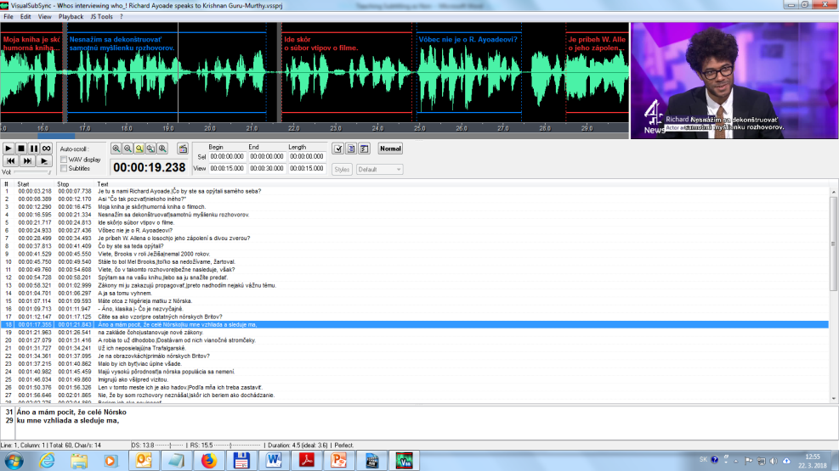
Fig. 1. VisualSubSync interface.
Aegisub has many professional functions, e. g. positioning of the subtitles and it can save subtitles in different formats – ass, srt, sub, etc. The audiotrack in Aegisub can to some extent mute background music and noises.
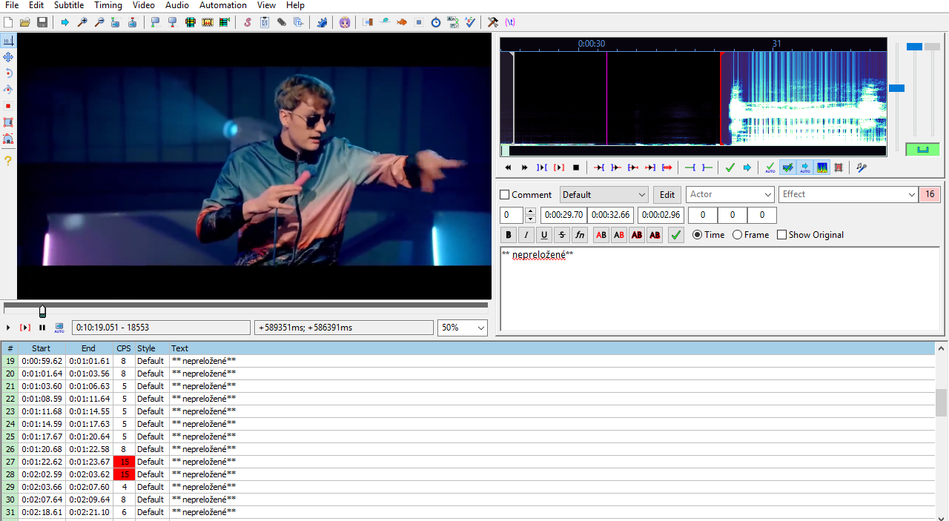
Fig. 2. Aegisub interface.
In all three programmes, students are able to set the preferred settings – CPS, too long/short duration of a subtitle, too long line of a subtitle and too short pause between subtitles (this last criterion is not included in Aegisub). There is also a possibility to shift the timing of the whole document at once in all three programmes.
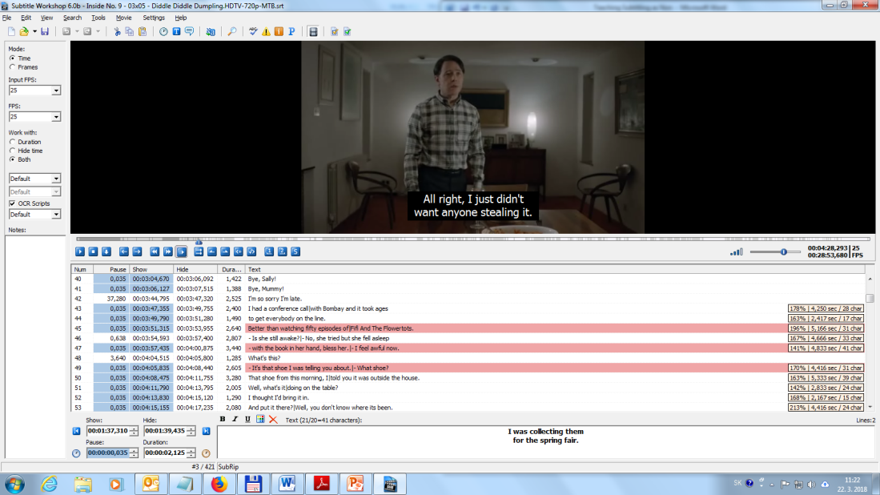
Fig. 3. Subtitle Workshop interface
The programmes automatically check the technical standars of subtitles and warns translator about errors by highlighting subtitles or time code (as seen in the figures, it highlights certain technical issues – this does not apply to VisualSubSync). However, it has to be stressed, that the final proofreading should be done in a word processor (MS Word, OpenOffice, etc.) – the subtitles are opened in notepad and then copied to the word processor, where the function Spelling & Grammar can be used. The last process of proofreading of subtitles is done by watching the video with subtitles and visually checking readibility.
It is possible that the programmes have difficulty to read all video digital formats, therefore students should be taught how to convert them online. It is not necessary to show how to spot and translate subtitles in all three programmes as they have similar interfaces and many online tutorials can be found online. Students should choose the programme that fit them (and their hardware) best and should be aware of the differences in functions. Following activities are proposed within lessons 9 –13:
- Give students a video interview without music in the background and let them practice the spotting. Give them instructions about the value of CPS you want them to achieve – 15 CPS is a good starting point. In the video, people should talk over each other, so the students can practice their info-mining skill as well.
- Students should remake the subtitles with 12 CPS. Discuss the differences.
- Give students video with the subtitles in the original language and let them come up with the solutions how to edit the spotting of the subtitles in the target language.
- Give students a short video clip in a format not supported by the aforementioned software and let them convert it. Discuss the differences between various video formats.
- Give students a context-based video clip and let them create subtitles. Pick one student and show their subtitles to the class. Discuss them and let other students improve them. Pinpoint errors and well-translated or well-spotted passages as well.
3 Criteria for Assessment of Subtitles
There are obviously many ways to assess a course. Following assessment is based on the premise that each student submits subtitles with 100 subtitle lines, ideally, with their own spotting as the final assessment – of course, continuous assessment throughout the course is needed as well. In terms of assessment the quality of translation, teacher has to assess adhering to technical standards as well. Before the assessment process, teacher should be in the role of a client and give students all necessary technical details to which they tailor the technical standards of subtitles. The outcome of the course by the students should be to create subtitles on their own for a video (of their own choice or selected by the teacher). Table 1 includes our proposal for the assessment of subtitles, which is based on Pedersen’s FAR model:
Table 1. Subtitling 101 assessment table
70 – 65 points | 64 – 61 points | 60 – 56 points | 56 – 51 points | 51 – 44 points | 43 – 0 points
A | B | C | D | E | FX

Points are reduced based on the following table:
Table 2. Assessment of subtitles
Translation evaluation |  | Evaluation of technical standards
Minor mistakes (grammar, style, clarity) | -2 | Minor mistakes (minor spotting faults, wrong punctuation) | -2
Serious mistakes (minor shifts in meaning) | -3 | Serious mistakes (serious spotting faults, pauses, CPS) | -3
Huge mistakes (serious shifts in meaning, serious omissions) | -4 | Huge mistakes (very serious spotting faults, pauses, CPS, many subtitle lines) | -4
Difficult passage well translated | +1/+2/+3 | Difficult passage well spotted | +1/+2/+3

After four-year experience and 140 students, it can be concluded that generally students are able to create average or above-average open subtitles. In the first year, the average points gained for subtitles were 50.5. During the second, third and fourth year the most common errors and deficiencies in the subtitles were taken into account and the proposed model was modified according to the deficiencies. Since then, the average points gained were 62. The most common deficiencies of students regarding the translation of subtitles are:
- not adhering to CPS – too long or too short display time of subtitles,
- too many characters per line – insufficient simplification,
- too many short consequent subtitles, which makes reading more difficult,
- inability to choose primary information,
- comprehensive interpretation.
These common faults were drawn from the assessment of subtitles. During the course, there should be more attention given to these areas.
4 Conclusion
There is a growing need to teach students of translation and interpreting to translate subtitles. However, in order to properly discuss the needs and perspective of AVT teaching in the future, a lot of research has to be made on the AVT market in Slovakia. We do not have specific and accurate data on the quantity of subtitling done in TV, cinemas or in other fields where subtitling is used – e.g. streaming services or social networks. The contacts with official companies providing audiovisual translation should be established, if students within the Translation study programmes are to be trained as audiovisual translators. Until then, more general model has to be used focusing on general subtitling knowledge rather than on specific field of subtitling, such as film captions or subtitles for hard-of-hearing. There is also a possibility that teaching subtitling can help to decrease the hypnosis of the original on the translation made by students, as in subtitling, students have to work within space and time restrictions, which force them to rephrase the utterances to larger extent and to translate pragmatic rather than semantic meaning. However, this is just a speculation and in order to quantify the effect further research has to be done.
In this paper, a model for teaching Subtitling 101 was proposed. The goal of this paper is not to provide step-by-step tutorial for teaching of subtitling, but rather to provide proposal for exercises that can be modified and tailored to the teachers’ needs (and to the market’s needs). AVT in Slovakia is a dynamic field which has to be studied closely in order to properly integrate the AVT courses within the Translation and Interpreting study programme.

Resumé
Cieľom článku je navrhnúť didaktický model určený na vyučovanie titulkovania v odbore prekladateľstvo a tlmočníctvo. Model vychádza z kompetencií nutných pri procese titulkovania, z problémových aspektov pri audiovizuálnom preklade a aj z praxe autora.

Bibliography
Caroll, M., Ivarsson, J. (1998). Subtitling. Simrishamn: TransEdit, 1998. 185 p. ISBN 91-971799-2-2.
Chaume, F. (2013). Translation for Dubbing: Expanding Borders. Presented at Media for All 5, 26. 9. 2013 Dubrovnik, Chorvátsko; available online <http://mediaforall5.dhap.hr/ Programme>.
Díaz, C. (2008). The Didactics of Audiovisual Translation, John Benjamins Publishing Company, 2008, ISBN 978 90 272 1686 1.
Gile, D. (1995). Basic Concepts and Models for Interpreter and Translator Training. Amsterdam &Philadelfia : John Benjamins, 1995. 283 p. ISBN 9789027224330
Janecová, E., Želonka, A. (2012). Didaktika prekladu pre audiovizuálne médiá : výzvy, možnosti, perspektívy. In Preklad a tlmočenie 10 : Nové výzvy, prístupy, priority a perspektívy. Banská Bystrica : Fakulta humanitných vied Univerzity Mateja Bela v Banskej Bystrici, 2012. ISBN 978-80-557-0444-9 , pp. 359-369.
Janecová, E. (2014). Audiovizuálny preklad : teória vs. prax. In Audiovizuálny preklad : Výzvy a perspektívy. Nitra : Univerzita Konštantína Filozofa v Nitre, 2014. ISBN 978-80-558-0572-6, pp. 51-60.
Janecová, E. (2012). Preklad pre audiovizuálne médiá v kontexte slovenskej teórie, kritiky a didaktiky prekladu. In Prekladateľské listy I. Teória, kritika, prax prekladu. Zborník štúdií a študentských prác zo XVI. ročníka Prekladateľskej univerziády. Bratislava: Univerzita Komenského, 2012. ISBN 978-80-223-3219-4. pp. 22-29.
Karamitrouglou, F. (1998). A Proposed Set of Subtitling Standards in Europe. In: Translation Journal 2 (2), April, 1998.
Klimová, K. (2012). Slovensko - dabingovo-titulkovacia krajina? In: Preklad a tlmočenie 10: nové výzvy, prístupy, priority a perspektívy, medzinárodná konferencia, Banská Bystrica 2011. Ed. Biloveský Vladimír, Banská Bystrica: Univerzita Mateja Bela, Fakulta humanitných vied, 2012, pp. 102-109. ISBN 978-80-557-0444-9.
Makarian, G. (2005). Dabing : Teória, realizácia, zvukové majstrovstvo. Bratislava : Ústav hudobnej vedy Slovenskej akadémie vied, 2005. 123 p. ISBN 80-89135-03-X.
Pedersen, J. (2017). The FAR model: assessing quality in interlingual subtitling. In: The Journal of Specialised Translation, Issue 28, pp. 210 - 229.
Paulínyová, L. Peréz, E. (2021) Integration of audiovisual translation training into a translation study programme. In Translation and interpreting training in Slovakia (ed. Djovčoš – Šveda et. al.), Univerzita Komenského v Bratislava, 2021. ISBN 978-80-8127-320-9, pp. 138 – 156
Perez, E., Paulínyová, L. (2018). Výučba audiovizuálneho prekladu na Slovensku. In: Didaktika prekladu a tlmočenia na Slovensku (ed. Djovčoš – Šveda et. al.), Univerzita Komenského v Bratislave, 2018, ISBN 978-80-223-4469-2. pp. 178 – 202.
Pošta, M. (2011). Titulkujěme Profesionálně. Apostrof, 2011, ISBN 978-80-904887-9-3.
Reichwalderová , E. (2015). The intertwinning of interpreter and subtitler competences in the learning process within the field of study - translation and interpreting . In Edukácia [vedecko-odborný časopis] 1 (2), 189 – 194. Košice : Univerzita Pavla Jozefa Šafárika, 2015. - ISSN 1339-8725.

Mgr. Matej Laš, PhD.
Katedra anglistiky a amerikanistiky,
Filozofická fakulta Univerzity Mateja Bela v Banskej Bystrici
Slovakia
matej.las2@umb.sk

However, the absence of such courses is partially compensated by various workshops regarding audiovisual translation. The workshops have been organized in cooperation with various specialists, institutions and with prominent figures from film or translation areas (Janecová, 2012). Slovak Association of Literary Translation (SSPUL) has also organized various events and seminars for universities. The audiovisual translation is also taught at non-translation programmes, e.g. at Academy of Performing Arts in Bratislava (Janecová, Želonka, 2012). Complex overview of audiovisual courses at Slovak universities is given in Peréz – Paulínyová (Djovčoš, Šveda, 2018).
Klimová (2011, s. 102 – 109)
However, there is not enough data on subtitling within Slovakia in order to properly establish AVT training within Slovak universities. In order to accurately state the aims of such course, market research is needed.
This competence is taught at Matej Bel University within the course „Praxeology“.
Freeware software do not provide option to hardcode subtitles, however, students can try to hardcode subtitles in various online applications or in other software – e.g. VLC player.
Gromová, Hodáková, Perez, Záhorák (2016): Audiovizuálny preklad a nepočujúci divák (Problematika titulkovania pre nepočujúcich)
E.g. Netflix standards can be found here: <https://partnerhelp.netflixstudios.com/hc/en-us/articles/215758617-Timed-Text-Style-Guide-General-Requirements>
The difference between genres in regard to spotting should be discussed. Spotting of sitcoms and comedies should slightly differ, as it is preferable, that punchline is read by the viewer at the same time as heard by the original viewers.
Some competences of interpreters are similar to those of subtitlers. Reichwalderová (2015) proposed subtitling as supplement and effective tool for teaching interpreting. She determines following similar competences needed for interpreting, that has to be also taught in subtitling: economization of the speech, interpreting sense for sense rather than word for word, mining of an invariant in the target language. Such competences correspond to the aforementioned competences of audiovisual translators stated by Makarian (2005) and Janecová (2014). Perhaps the most important of these competences is info-mining. Complex interpretation in subtitling is of crucial importance, as the translator has to translate explicitly – to make interpretation of viewers easier and to maximize their ability to focus on the video rather than on the subtitles – as well as simplified – two boundaries.
Basic knowledge of terms from Film Studies can also significantly improve the overall quality of subtitles. Students should be aware of the differences between hard cuts and jump cuts. Subtitles should not intervene into two hard cuts (cut from scene A to scene B), but can intervene into two jump cuts (cuts within the same scene).
This function is also provided by Subtitle Workshop and Aegisub, however, it does not support all languages.
There is also an option to left students with no details and wait for their response. They should then ask teacher about the technical issues, if not, they have to be notified about such need in their future careers.
Pedersen, J. (2017). The FAR model: assessing quality in interlingual subtitling. In The Journal of Specialised Translation, Issue 28, pp. 210 - 229.
More on segmentantion of subtitles: < https://bop.unibe.ch/JEMR/article/view/4267>

