Immigration: Give and take
Broad claims about the impact of immigration hide big variations
Oct 18th 2007
BOTH the pro- and anti-immigration lobbies pounced with glee on two official reports published on October 16th. Those who delight in Britain's hoovering-up of foreign workers championed a Home Office study which found that immigrants contributed £6 billion to the economy last year and are harder workers than native Britons. Those who fret about foreign freeloaders brandished a separate report—from that very same department—which warned that immigration was putting a strain on services such as housing, health and policing in many parts of the country.

Such is the increase in immigration to Britain that evidence can be found to back up almost any theory about its pros and cons. Immigration started to outweigh emigration in the 1980s and really took off a decade ago, when the government began handing out more work permits, universities wooed international students and applications for political asylum rose (these have since dropped off). At the end of last year foreign-born workers made up 12.5% of the labour force, up from 7.4% in 1997. Today, one in four babies born in Britain has a foreign parent.
Famously, the big increase of recent years has been in Poles, whose numbers have swollen from a little over 50,000 in 1996 to well over 300,000 (and some say twice that). But nearly every nationality is now present in greater numbers than before: during the same period, Britain's French population nearly doubled; Sri Lankans and Filipinos more than trebled. Britain is importing not only more workers to perform undesirable “3D” jobs—those that are dirty, dangerous and difficult—but also more high-fliers on super-salaries.
In terms of earnings, the most successful are the Americans (see table), who command higher wages and work longer hours than any other immigrant group. Canadians, Australians and South Africans are the next-biggest earners, according to a report released last month by the Institute for Public Policy Research, a leftish think-tank. Yet rich countries do not always produce the richest migrants, points out Danny Sriskandarajah, the report's author: Nigerians fare better than Portuguese, and Ugandans earn nearly twice as much as Turks.
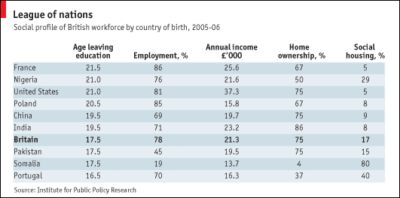
A migrant's fortunes are largely determined by his reason for coming to Britain. Australians, Poles and Filipinos, who come primarily for jobs, are employed in far greater proportion than British-born residents. By contrast, some new arrivals are legally prevented from working: Somalis' woeful 19% employment rate is partly down to the fact that many start off as asylum-seekers, who cannot work until their application is cleared, usually after more than six months. Others move to Britain to join family members or to marry. Half of all Pakistan-born residents are economically inactive, thanks in part to the fact that many come in order to start families rather than careers.
Whatever the prospects of recent arrivals, they do not necessarily predict how the next generation will fare. Achievement at school is usually linked to family income, so one might expect children from poorer immigrant backgrounds to slip up. But they don't. Immigrants from China earn less than the national average and are less likely to be in work, but their children trounce all comers at school—and are hotly followed by children classified as Indian or “other Asian”.
Immigrants from most countries spend longer in full-time education than Britons. For first-generation migrants, this often fails to translate into higher wages. But it seems to give a heck of a boost to their children—and it is on them that the success or failure of Britain's immigration experiment will ultimately depend.

Source: The Economist. Available at https://www.economist.com/britain/2007/10/18/give-and-take
Accessed: December 16th, 2018

